

Subscribe to DeepL Pro to edit this document.  
Visit [www.DeepL.com/pro](https://www.deepl.com/pro?cta=edit-document) for more information.

# DEVELOPMENT OF METHODS FOR PRODUCTION OF MULTICOMPONENT FLAME RETARDANTS FROM LOW-GRADE PHOSPHORITES AND WASTES OF THE KYZYLKUM PHOSPHORITE COMPLEX

**Muratova Manzura Nemadjanovna**

Introduction. In the modern world today through the effective use of mineral raw materials, mining and chemical wastes mineral fertilizers of special importance for the national economy, binding agents, synthetic detergents and flame retardants are obtained. In the Kyzylkum phosphorite complex, as a result of increasing the volume of mining and processing of ores, scientific research is being conducted to develop a method to reduce the negative impact on the environment of accumulated low-grade ores. In this connection, special attention is paid to the necessary increase of the main component in them (P2 O5 -10-15%) through the improvement of beneficiation processes, organization of an effective process of low-temperature decarbonization, purification of fluorine-containing impurities, extraction of rare-earth metals, as well as the creation and introduction of technologies for obtaining new types of inorganic products from silicate and aluminate by-products.

A number of scientific and practical results are being achieved in the country through the introduction of advanced science-based measures to improve production technologies, production of flame retardants with the rational use of secondary resources, increasing the economic efficiency of production indicators. According to the Decree of the President of the Republic of Uzbekistan for 2022-2026 "...to continue the realization of industrial policy aimed at ensuring the stability of the national economy, increasing the share of industry in the gross domestic product and increasing the volume of industrial production by 1.4 times...". Proceeding from these tasks, research aimed at obtaining non-traditional inorganic materials, including flame retardants, from low-grade raw materials and wastes containing phosphate fertilizers with additional components of secondary industrial raw materials is of great scientific and practical importance.

Analysis and Results. All four samples of low-grade phosphorites belong to granular jelly phosphorites with substandard content of the main component - P2 O5  , varying from 10 to 15%. The results of chemical and mineralogical composition, granulometric characteristics obtained by spectral, XRD and sieve analyses are given in Table 1 and in Figures 1-6. Analysis of these results show that chemical and mineralogical compositions of the studied four samples do not differ much from each other.

**Dust fraction (PF)** is fine (0.055-0.1mm) solid emissions (capacity of 100 thousand tons per year), production of thermally enriched phosphorite of Central Kyzylkum. Diffractorgrams were taken to study and establish the chemical and mineralogical composition (Fig.1.).

According to the results of X-ray phase analysis, the mineralogical composition of the dust fraction includes the following types of compounds: Calcite (46.3%) - CaCO₃; Fluorapatite (45.5%) - Ca .45 (PO )43 ∙0.5CaF ;2

Brushite - CaHPO₄-2H₂O (1.7%); Microline - KAlSi₃O₈ (0.9%), Quartz (4.3%); Illite (K,Na,Ca,H₃O⁺)(Al,Fe,Mg)₂(Si₃Al)O₁₀(OH)₂-(H₂O,K⁺)(x-2) 1.8%; Calcium fluoride, CaF₂ (0.1%); Fluorostrophite, BaMnFe(PO₄)₃(OH,F,Cl) (1.2%).

Ftorapatite (45.5%) - Ca .45 (PO )43 ∙0.5CaF2 PCO 0(2Ө/d(Ǻ): 219,84/4,473, 20,79/ 4,27, 26,64/ 3,446, 30,81/2,90, 32,03/2,79, 36,01/2,49, 43,21/2,09). Symmetry group P 63/m, crystal system is hexagonal, calculated density 3.340 g/cm3 [131, P. 1406-1414].

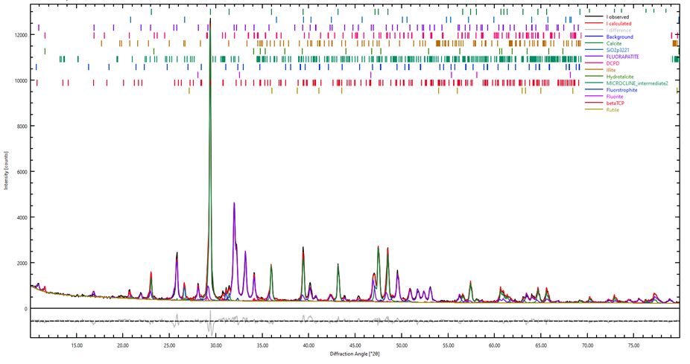

**Figure 1. Radiograph of the initial PF**

Microcline (0.9%) - K(AlSi O38 ) (A = 8.290Ǻ, B = 12.96 Ǻ, C = 7.15 Ǻ). Semmetry Group C-1. Specific gravity:2.54 - 2.57, crystal system: triclinic [132; P.219-224, 133; P.1593-1605].

Quartz (4.3%,) - SiO2 (2Ө/d(Ǻ): 10,94/8,085, 22,29/3,986, 23,06/3,854, 25,84/3,446, 34,19/2,62, 36,01/2,49). Symmetry group P nma, crystal system is orthorhombic, calculated density 2.627 g/cm3 [134; P. 215-229, 135; P. 2204-2212, 136; P. 588-593].

The last mineral by its chemical composition can be referred to the polyelement type with the highest density of the above minerals in the dusty fraction.

**Phosphorite meal of off-balance ore 1 layer (FP1)**, gray color with dispersity from 0.5 to 1.0 mm sample, belongs to the jelly-clay rock of phosphorites, according to the results of X-ray phase analysis (Fig.2, Table 1.) consists of the following varieties: calcite (48.1%) - CaCO₃; fluorapatite (35.7%) - Ca .45 (PO )43 ∙0.5CaF ;2  brushite - CaHPO₄-2H₂O (4.5%); microline - KAlSi₃O₈ (2.0%); rutile - TiO₂ (0.5%,); illite (K,Na,Ca,H₃O⁺)(Al,Fe,Mg)₂(Si₃Al)O ₁₀(OH)₂ -(H₂O,K⁺)(x-2) 2.9%; quartz (2.9%,); hydrotalcite - Mg₆Al₂(OH)₁₆-CO₃-4H₂O (3.4%).

Ftorapatite (35.7%), - Ca ,45 (PO )43 ∙0.5CaF2 (9:1 or 90/10%) XRF data are given above, the only difference is the calculated density value of 3.195 g/cm3 [137; P. 1333-1345].

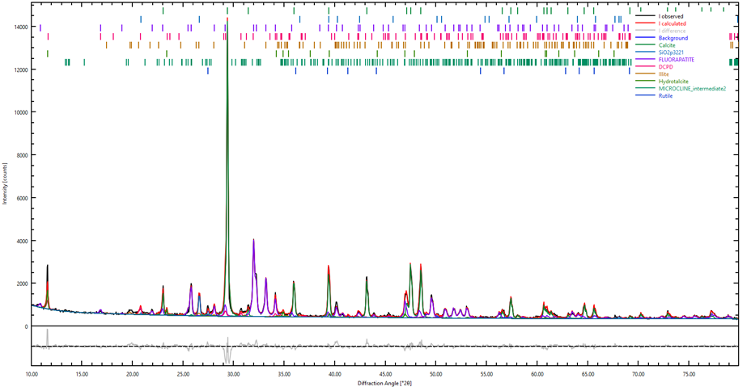

**Figure 2. Radiograph of the original FP1.**

**Phosphorite meal of the 2nd layer (PF2)**. According to external signs, the phosphorite sample from the second layer is also similar to the sample of PF1, but according to the X-ray phase analysis differs in the set of minerals and the content of chemical elements (Fig.3)The presence of minerals in PF2 (%) was noted: fluorapatite - Ca5 (PO )43 F (45.6%); calcite - CaCO₃ (42.7%); brushite - CaHPO₄-2H₂O (1.6%); quartz - SiO2 (1.3%); microcline KAlSi₃O₈ (1.4%);

illite - (K,Na,Ca,H₃O⁺)(Al,Fe,Mg)₂(Si₃Al)O₁₀(OH)₂-(H₂O,K⁺)(x-2) (4.7%); Tri-basic calcium phosphate - Ca₃(PO₄)₂ (1.1%); clinoptilolite (Na,K,Ca,Mg,Al)6 Al9 (Si29 Al9 )O72 -20H₂O (1.7%); DCPD - 1.4 times more than in the FP1 sample.

The contents of Ca, P, F, Fe, K in FP2 are higher, and Al and Si are much lower than in FP1. The ratios of the main components are,%: P O25 /SiO2  = 6.32, P O25 /Al O23  = 34.4, Al O23 /Fe O23  =0.36, SiO2 /Al O23 = 8.8.

Overall, this NSF sample has a much higher total phosphate ratio (87.2%) compared to silicate minerals (13.8%), accounting for 83.0% phosphate and 17.0% silicate in PF, and 66.6% phosphate and 33.4% silicate in FP1, with the same 83.3% identification of manifested peaks in the refractograms (unidentified - 17.2%).

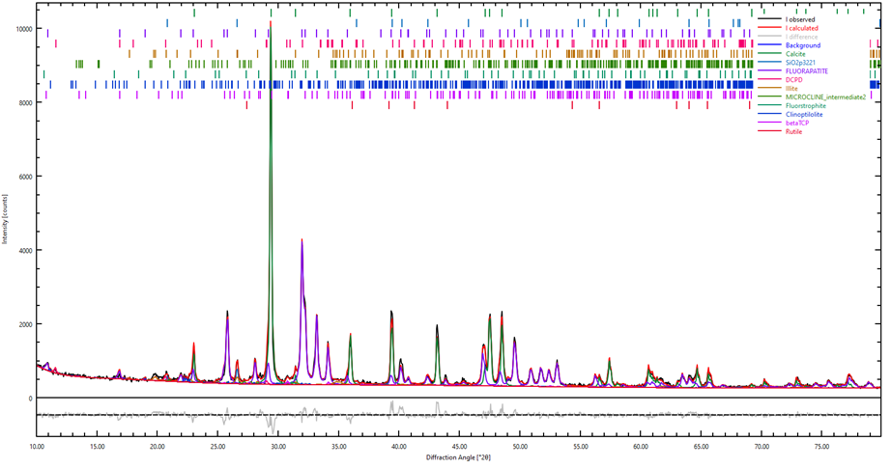

**Figure 3. Radiograph of the original FP2.**

The amount of water-soluble components in PF2 (Na 2.5%, K 0.6%, sum 3.1%) is less, compared to those in PF1 (Na 3.3%, Cl 0.7%, K 0.2%, sum 4.2%). Note that in the data on the chemical composition of the dust fraction (PF) there is no information on the content of Na and Cl, which is apparently due to their removal in the technological process of obtaining washed and thermo-enriched products, dust-like waste, which is the NSF sample studied by us.

***Mineral mass.*** According to the results of X-ray phase study 30 % of peaks detected in the diffractogram of the mineral mass sample were identified and the presence of four minerals was revealed. According to the results of X-ray analysis the mineralogical composition of the mineral mass counts the following varieties (Fig4.): fluorapatite - Ca5 (PO )43 F (37.0%); calcite - CaCO₃ (50.7%); quartz - SiO2 (1.8%) - 0.1; brushite - CaHPO₄-2H₂O (3.5%); rutile - TiO₂ (0.4%); microcline - KAlSi₃O₈ (1.7%); illite - (K,Na,Ca,H₃O⁺)(Al,Fe,Mg)₂(Si₃Al)O₁₀(OH)₂-(H₂O,K⁺)(x-2) (3.8%); hydrotalcite - Mg₆Al₂(OH)₁₆-CO₃-4H₂O (1.2%).

Among them, hydroxyapatite (62.3%) has a predominant content, which is three times higher than that of another major phosphorus-bearing mineral - fluorapatite (20.6%). Silicon containing rock is represented as an aluminomagnesium orthosilicate mineral, pyrope (13.7%). The remaining part (3.4%) consists of a polyelemental mineral (phlogopite) hydroxofluorosilicate of metal ions (Mg, Ti, Fe, Al, K, Na, Ba).

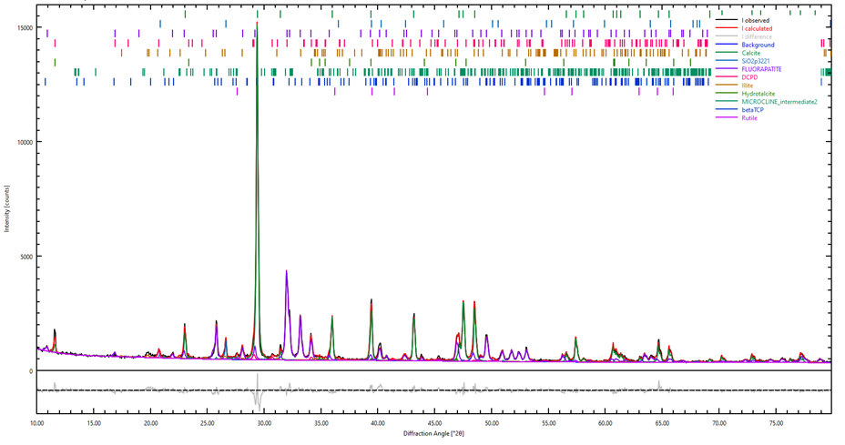

**Figure 4. Radiograph of the original MM**

According to the results of XRD study of initial NSF samples, the main minerals in the selected phosphorites are hydroxyapatite, fluorapatite, displaced ortho-, metaphosphates of iron, potassium, and calcium, magnesium, less often strontium-bearing phosphates. Silicate constituents of aluminum, magnesium, iron, calcium, and quartz are less abundant than phosphate constituents. Carbonate rocks are found in the form of calcite in the mixture of dolomite occurrence, possibly with the presence of trace amounts of isomorphic Mn+2 (0.2÷0.08%), Cu+2 (0.005÷0.008%), VO+2 (0.002÷0.005%). The presence of the above-mentioned chemical and mineralogical constituents in the composition of low-grade phosphorites is proved by ICP-AES, IR and EPR spectroscopy and MZA.

Semi-elemental silicate rocks with higher calculated density (4.0-4.3 g/cm3 ) occur in the composition of low-grade phosphorites up to 4-5 %. In order to control the processes and products of acid processing of these samples of low-grade phosphorites, in order to obtain phosphate, silicate and aluminate-containing flame retardant compositions, it is necessary to pay attention to changes in the compositional and structural features of the detected minerals using modern physicochemical methods of research.

Hydrochloric acid by composition and chemical nature is a strong acid reagent, which is traditionally used in the processing of various mineral raw materials, especially apatite and phosphate. Taking into account this feature of both acid reagent and multicomponent phosphate raw materials, in order to obtain a solution with the highest content of phosphate, Al+3 , Fe+3 , Cl- and partially silicon-containing ions, experiments on decomposition of low-grade phosphorites of Central Kyzylkum by hydrochloric acid solutions with different concentrations were carried out.

Flame retardant properties of solutions and solid residues obtained after hydrochloric acid processing for flame retardancy of cellulosic materials have been studied. All 4 varieties (PF, FP1, FP2, MM) of low-grade phosphate rock and 5, 10 and 20% HCl solutions were used for the study, respectively ρ = 1.023, ρ = 1.047, ρ = 1.098 g/cm3 and with consumption rates of 28.53, 58.3 and 121.6% for carbonate components of HCl. Processing of low-grade phosphate rock with HCl solutions was carried out in the following general way. 50 g of finely ground (0.05-1.0 mm) sample of low-grade phosphate rock from Central Kyzylkum were placed in a 200 ml container and, while stirring, in portions of 12-15 ml, the following volumes of acid solution were added 50 ml (T:L = 1:1) , 100 ml (T:L = 1:2) and 150 ml (T:L = 1:3) of 5% - solution HCl for 20 minutes. The method of adding 12-15ml of acid solution in portions was used to prevent the abundant foaming observed during acid processing of highly carbonized phosphorite samples. At the ratio of T:L=1:1 we obtained a wet thick mass of phosphorite with the appearance of bubbles of released gas, further increase in the volume of acid solution up to 100 ml led to the formation of thick suspension, with intense gas release.

In this case, the formed very thick slurry was possible mechanical stirring, accompanied with increased gas release. To liquefy the suspension during stirring (speed of rotation of electric stirrer 120 rpm) continued to increase the volume of added acid solution up to 150 ml, obspecichivaya at the end of the process ratio T:L = 1:3. In this case a suspension with pH = 4.1, with slow gas release was formed, which was heated to 60-70о C for 30 minutes with more intensive stirring (140 rpm), after that the pH of the medium decreased to 3.0, which was controlled by measuring the device pH-meter/conductometer "FiveEasy (pH/mv) combined glass electrode LE438.

At the end of processing a pulp was formed, which was sedimented for 30 minutes and note that, at the same time, a gradual increase in pH to 3.4 was observed (apparently, due to the continuation of the reaction of ions H3 O+ with unreacted difficult to process phosphate constituents). The liquid phase - mother liquor was separated from the sediment by filtration, the masses of solid phases of low-grade phosphorite samples after drying were 43.08g (86.16%) of mineral mass - 41.80g (83.80%) of dust fraction from the initial phosphorite mass (50 g). According to the mass difference before and after processing, the solubility of low-grade phosphorite samples in 5% HCl solution was found to be 13.84% (6.92g) of mineral mass -16.40% (8.20g) of dust fraction.

The compositions of the liquid phase and solid phase were analyzed by the methods given in Section 2. The results are given in Tables 1 and 2.

The obtained yellowish transparent solutions (pH = 4.0-4.7) containing flame retardant components (CaO, P2 O5 , SiO2 , Al2 O3 Fe2 O3 )+Cl- )+Cl were further used for impregnation of samples of flame retardant materials. The filtered and dried residue obtained after the processing of low-grade phosphate rock was used to study the flame retardant property as a solid flame retardant composition.

The interaction of low-grade phosphorite samples during processing with 5% hydrochloric acid solution occurs in the mode of "insufficient acid rate" (28.53%) relative to the main components (fluorapatite, carbonatefluorapatite, calcite, dolomite) of phosphorite raw material.

Table 1

Results of analysis of liquid phases of slurries obtained by NSF processing

with solutions of hydrochloric acid and different concentrations

ΣАПК is the sum of the content of flame retardant components.

|  |  |  |  |  |  |  |  |  |  |  |
| --- | --- | --- | --- | --- | --- | --- | --- | --- | --- | --- |
| **NSF variety** | **Content of main components, % (g/l)** | | | | | | | | | |
| **SiO2** | **P2 O5** | **Al O23** | **Fe O23** | **CaO** | **MgO** | **Na O2** | **K O2** | **Cl-** | **Dissolve-**  **gravity, g / %** |
| Solution obtained by processing with 5% HCl solution | | | | | | | | | | |
| Dust fraction (PF) | 0,62 | 3,26 | 0,53 | 0,42 | 8,57 | 0,86 | 1,79 | 0,34 | 2,53 | 8,2 / 16,39  ΣАПК = 7.36 |
| Phosphorite from bed 1 (FP1) | 0,72 | 3,38 | 0,48 | 0,39 | 8,82 | 0,79 | 1,91 | 0,36 | 2,37 | 7,93 / 15,85  ΣАПК = 7.34 |
| Phosphorite from 2 strata (FP2) | 0,68 | 3,31 | 0,52 | 0,44 | 7,93 | 0,89 | 1,80 | 0,39 | 2.49 | 7,98 /15,96  ΣАПК = 7.44 |
| Mineral Mass(MM) | 0,47 | 2,69 | 0,37 | 0,40 | 7,12 | 0,68 | 1,73 | 0,38 | 2,33 | 6,92 /13,84  ΣАПК = 6.26 |
| Solution obtained by processing with 10% HCl solution | | | | | | | | | | |
| Dust fraction (PF) | 1,41 | 9,30 | 0,83 | 0,62 | 19,6 | 1,31 | 2,72 | 0,58 | 5,18 | 21,57/ 43,34  ΣАПК = 17.34 |
| Phosphorite from bed 1 (FP1) | 1,37 | 8,96 | 0,82 | 0,69 | 19,9 | 1,36 | 2,90 | 0,63 | 5,24 | 21,39/42,78  ΣАПК = 17.14 |
| Phosphorite from 2 strata (FP2) | 1,28 | 9,11 | 0,79 | 0,74 | 19,8 | 1,43 | 2,87 | 0,67 | 4,97 | 21,56/43,11  ΣАПК = 16.89 |
| Mineral Mass(MM) | 0,93 | 8,12 | 0,65 | 0,58 | 18.9 | 0,98 | 2,24 | 0,42 | 5,12 | 19,92/39,83  ΣАПК =15.40 |
| Solution obtained by processing with 20% HCl solution | | | | | | | | | | |
| Dust fraction (PF) | 3,01 | 11,43 | 0,95 | 0,92 | 28,7 | 1,71 | 3,87 | 0,56 | 10,86 | 33,72/67,45  ΣАПК =27.17 |
| Phosphorite from bed 1 (FP1) | 2,64 | 11,2 | 0,90 | 0,96 | 27,9 | 1,60 | 3,68 | 0,59 | 11,68 | 32,01/64.02  ΣАПК =15.22 |
| Phosphorite from 2 strata (FP2) | 2,57 | 11.3 | 0,93 | 0,86 | 26,7 | 1,14 | 3,76 | 0,54 | 11,06 | 33,30/66,58  ΣАПК = 27.79 |
| Mineral mass (MM) | 2,21 | 8,96 | 0,71 | 0,78 | 27,0 | 1,31 | 2,32 | 0,43 | 11,42 | 31,05/62,01  ΣАПК = 24.08 |

A set of chemical reactions can be expressed by equations:

CaCO3 ∙MgCO3 +4HCl = CaCl2 + MgCl2 +2CO2 + 2H2 O (1).

2Ca10 (PO ) F452 (CO ) +20HCl=10CaHPO31,542 +10CaCl+CaF+3CO2 +3H2 O (2).

Table 2

Results of analysis of solid phases of slurries obtained by processing low-grade phosphate rock with hydrochloric acid solutions and different concentrations

ΣАКП is the sum of the content of flame retardant components.

|  |  |  |  |  |  |  |  |  |  |  |
| --- | --- | --- | --- | --- | --- | --- | --- | --- | --- | --- |
| **NSF variety** | **Contents of main components, %** | | | | | | | | | |
| **SiO2** | **P2 O5** | **Al O23** | **Fe O23** | **CaO** | **MgO** | **Na O2** | **K O2** | **CO2** | **Residual solid phase, g / %** |
| Solid phase obtained by processing with 5% HCl solution | | | | | | | | | | |
| Dust fraction (PF) | 8,52 | 12,56 | 1,84 | 1,38 | 33,93 | 1,22 | 2,28 | 0,56 | 10,30 | 41.43 / 82.86 ΣАПК = 34.54 |
| Phosphorite from bed 1 (FP1) | 7,91 | 11,14 | 0,98 | 0,86 | 35,56 | 1,86 | 2,93 | 0,46 | 11,74 | 41,88 / 83,76  ΣАПК = 32.64 |
| Phosphorite from 2 strata (FP2) | 10,34 | 11,44 | 0,74 | 0,52 | 31,58 | 0,75 | 3,64 | 0,35 | 12,31 | 41,96 /83,91  ΣАПК = 35.34 |
| Mineral mass (MM) | 12,29 | 8,34 | 1,14 | 0,91 | 37,93 | 2,14 | 1,08 | 0,17 | 14,06 | 42,88/85,74  ΣАПК = 36.74 |
| Solid phase obtained by processing with 10% HCl solution | | | | | | | | | | |
| Dust fraction (PF) | 7,74 | 6,46 | 1,63 | 1,17 | 22,78 | 0,85 | 1,36 | 0,34 | 2,92 | 28,27/ 56,54  ΣАПК = 19.92 |
| Phosphorite from bed 1 (FP1) | 7,17 | 5,56 | 0,64 | 0,55 | 24,49 | 1,37 | 1,96 | 0,18 | 3,32 | 28,62/57,23  ΣАПК = 17.24 |
| Phosphorite from 2 strata (FP2) | 9,78 | 5,73 | 0,46 | 0,21 | 19,54 | 0,21 | 2,49 | 0,09 | 4,78 | 28,40/56,78  ΣАПК = 20.96 |
| Mineral mass (MM) | 11,84 | 4,65 | 0,86 | 0,73 | 26,17 | 1,85 | 0,54 | 0,12 | 5,46 | 30,15/60,03  ΣАПК = 23.58 |
| Solid phase obtained by processing with 20% HCl solution | | | | | | | | | | |
| Dust fraction (PF) | 6,24 | 3,41 | 1,52 | 0,86 | 13,84 | 0,45 | 0,17 | 0,36 | 0,8 | 16,27/32,47  ΣАПК = 12.83 |
| Phosphorite from bed 1 (FP1) | 6,01 | 3,18 | 0,54 | 0,28 | 16,76 | 1,16 | 1,17 | 0,22 | 0,72 | 17,95/35.98  ΣАПК = 10.73 |
| Phosphorite from 2 strata (FP2) | 8,53 | 3,47 | 0,33 | 0,08 | 12,69 | 0,46 | 1,61 | 0,18 | 0,84 | 16,70/33,40  ΣАПК = 13.25 |
| Mineral mass (MM) | 10,59 | 2,06 | 0,78 | 0,54 | 18,12 | 1,51 | 0,48 | 0,11 | 2.54 | 18,41/36,83  ΣАПК = 16.87 |

It should be noted that the peculiarity of the reactions occurring during the interaction of 5% HCl solution with samples of low-grade phosphorites is the rapid reaction of water-soluble salts of ions Na+ , K+ , Mg+2 , Ca+2 and partial decomposition of easily accessible to interaction with ions H3 O+  carbonates such as exocalcite, as well as fluorapatite. This is evidenced by the results of microprobe analysis of the solid phase (Appendix 3) and chemical analysis of the content of Na2 O, K2 O, MgO, CaO in the solution obtained after processing with 5% hydrochloric acid solution, corresponding to more than 30% of their content in the original samples of low-grade phosphorites and IR spectra (Table 2 and Fig. 2.). Although the acid solution used is weaker for the processing of phosphorite ores, however, to some extent contributes to the recovery (in wt %): SiO2 - 0.47- 0.72, P O25  - 2.19-3.38, Al O23  - 0.37-0.53 and Fe O23 - 0.39-0.44 of the major components contained in the amorphous phase of phosphorites into solution, because at this concentration, the crystalline phases of phosphorite constituents are acid persistent.

Nevertheless, when comparing the relative total solubility of the above four components of the low-grade phosphate samples, which will further constitute the flame retardant components, the following (not significantly different) trend of extraction into solution is observed: MM (3.93) < PF (4.82) < FP2 (4.95) < FP1 (4.97 %) (Table 2).

After acid processing of 50 g of initial solid samples of low-grade phosphate rock with 5% HCl solution, the residual masses of filtered solid phases from the resulting pulps were 43.08 - 41.80 g, and the solubility of low-grade phosphate rock samples was 13.84 - 16.40%. In general, the total solubility, depending on the type of low-grade phosphate samples, increases in the series: MM(13.84)<FP1(15.85)<FP2(15.96)< PF (16.39 %). It should be noted that the solubility of mineral mass is 2.55% lower compared to other samples of low-grade phosphorites, and the solubility of the last three samples differ from each other only by a maximum of 0.54%, so the solubilities of the samples of low-grade phosphorites can be considered almost the same.

The results of chemical analysis of the composition of all solid samples are shown in Table 1 and Fig. 5. It can be noted that the content of the main flame retardant components in the processed samples becomes relatively higher than in the original low-grade phosphate rock. This is explained by the minor enrichment of low-grade phosphorite samples during hydrochloric acid processing even at low acid rate - 28.53% (Table 4.) .

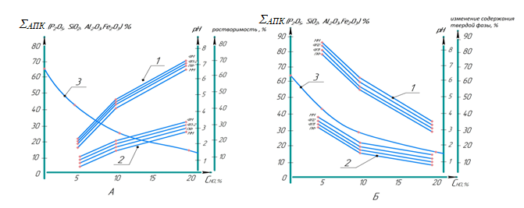

**Figure 5**. **Solubility dependence of low-grade phosphate rock**

**and flame retardant components from CHCl,%**

**А. 1-Change in solubility; 2-Change in ΣАПК  in the liquid phase; 3-Change in pH of the medium;**

**B. 1-Dependence of change in solid phase content, low-grade phosphorites on C ;HCl,%**

**2 - change of ΣАПК in the solid phase; 3 - change of pH of the medium**

This fact is apparently the result of dissolution of water- and acid-soluble components and partial decarbonization of dolomite-calcite components of processed samples of low-grade phosphorites.

In order to obtain a higher total content (ΣAPK P O25 , SiO2 , Al O23 , Fe O23 , Cl- )% of the combined composition of the liquid phase of the products of processing low-grade phosphate rock, 10 and 20% solutions of HCl were used, corresponding to acid consumption rates of 58,30 and 122% (Table 2). It should be noted that experiments on studying solubility depending on concentration (with 10 and 20% solutions) of hydrochloric acid and extraction into solution of flame retardant components in the processing of low-grade phosphorites were carried out by a similar method as with 5% HCl solution. The results are given in Tables 1 and 2.

As it was expected that the use of the specified concentrations of acid reagent solutions in the processing of samples of low-grade phosphorites contributed to an increase in the solubility of the solid phase and obtaining the liquid phase with the highest content of the main flame retardant components, as well as their associated compounds of other metal ions, as evidenced by the data in Table 1, and accordingly, there is a decrease in the mass fraction of solid phases and the content of flame retardant components in their composition (Table 2), in the acid processing of samples of Ni and Ni.

Comparative analysis and comparison of the influence of variety (more precisely, chemical and mineralogical composition and nature of constituents) of low-grade phosphorite samples on their solubility indicates that some differentiation of solubility depending on the concentration of acid reagent solution is observed only between mineral mass samples and the remaining three types of low-grade phosphorites with a difference interval of 2,55 % in case of 5%, 3.51 % in case of 10% and 6.44 % in case of 20% HCl solutions), and the similar difference of solubility between the three varieties (PF, FP1 and FP2) depending on the concentration of acid reagent is only 0.54, 0.56 and 1.64 %, respectively.

As expected, the solubility of low-grade phosphate samples in general, including the flame retardant components (ΣАПК ), increased markedly with increasing from concentration in the case of 10 and 20% hydrochloric acid solutions (Table 1).

At the same time, the composition of the liquid phase is most enriched with the components of fire retardant components, i.e. when higher concentrations of hydrochloric acid are used in processing (acid rates of 58,30 and 122%), the solubility of silicate-phosphate constituents increases. For example, in the liquid phase of processing products of low-grade phosphate samples with a solution of 5% HCl, the total fraction of ΣAPC(P O25 , SiO2 , Al O23 , Fe O23 , Cl- ) was 6.26 - 7.36% of 13.84 -16.39 % of total dissolved components.

The same figure in case of 10% HCl solution has 15.40 -17.34 of 39.83-43.34% and 24.08-26.79% of 44.01-50.45% constitutes of the total dissolved portion of low grade phosphorite samples when 20% HCl solution is used.

Comparative analysis of the obtained results revealed that with increasing hydrochloric acid concentration (up to 20%) there is a parallel, but opposite, change in the content of silicate and aluminate components in the liquid phase of the products of processed samples of low-grade phosphate rock. As a proof of it we can cite the data of increase of SiO /P22 O5 ratio from 0.152 to 0.263 (PF), from 0.153 to 0.235 (FP1), from 0.141 to 0.226 (FP2) and from 0.115 to 0.247 (MM) at transition from 10 % to 20 % HCl solution.The same, but opposite nature of changes in the ratio of Al O23 / P2 O5 from 0.0892 to 0.0831 (PF), from 0.0915 to 0.0801 (FP1), from 0.0867 to 0.0818 (FP2) and from 0.0800 to 0.0792 (MM) aluminum compounds undergo when going from 10% to 20% HCl solution.

Comparative analysis and comparison of the influence of variety (more precisely, chemical and mineralogical composition and nature of constituents) of low-grade phosphorite samples on their solubility indicates that some differentiation of solubility depending on the concentration of acid reagent solution is observed only between MM samples and the remaining three types of low-grade phosphorites with a difference interval of 2,55% in the case of 5%, 3.51% in the case of 10% and 6.44% in the case of 20% HCl solutions), and a similar difference in solubility between the three varieties (PF, FP1 and FP2) depending on the concentration of acid reagent is only 0.54, 0.56 and 1.64%, respectively.

As expected, the solubility of low-grade phosphate samples in general, including the flame retardant components (ΣАПК ), increased markedly with increasing from concentration in the case of 10 and 20% hydrochloric acid solutions (Table 1).

At the same time, the composition of the liquid phase is most enriched with the components of fire retardant components, i.e. when higher concentrations of hydrochloric acid are used in processing (acid rates of 58,30 and 122%), the solubility of silicate-phosphate constituents increases. For example, in the liquid phase of processing products of low-grade phosphate samples with 5% HCl solution, the total fraction of ΣAPC(P O25 , SiO2 , Al O23 , Fe O23 , Cl- ) was 6.26 - 7.36% out of 13.84 -16.39 % of total dissolved components. The same figure in case of 10% HCl solution has 15.40 -17.34 of 39.83-43.34 % and 24.08-26.79 % of 44.01-50.45 % constitutes of the total dissolved part of NSF samples when 20% HCl solution is used.

Comparative analysis of the obtained results revealed that with increasing hydrochloric acid concentration (up to 20%) there is a parallel, but opposite, change in the content of silicate and aluminate components in the liquid phase of the products of processed samples of low-grade phosphate rock.

As a proof of this we can cite the data of increase of SiO /P22 O5 ratio from 0.152 to 0.263 (PF), from 0.153 to 0.235 (FP1), from 0.141 to 0.226 (FP2) and from 0.115 to 0.247 (MM) at transition from 10% to 20% HCl solution.The same, but opposite nature of changes in the ratio of Al O23 / P2 O5 from 0.0892 to 0.0831 (PF), from 0.0915 to 0.0801 (FP1), from 0.0867 to 0.0818 (FP2) and from 0.0800 to 0.0792 (MM) aluminum compounds undergo when going from 10% to 20% HCl solution.

The study of the solid phase by X-ray phase analysis (Fig. 6 and Fig. 7) showed the presence of various mineral constituents found in the composition of processed samples of low-grade phosphorites by hydrochloric acid, so in the sample FP1 are present: Quartz - SiO2 (37%); Rutile - TiO₂ (1.1%); Gypsum - CaSO₄-2H₂O (4.29%); Illite - (K,Na,Ca,H₃O⁺)(Al,Fe,Mg)₂ (Si₃Al)O₁₀(OH)₂-(H₂O,K⁺)(x-2) (34.2). In the PF sample, the presence of the following varieties such as: fluorapatite Ca5 (PO )43 F (61.4%); rutile - TiO₂ (1.0%); quartz - SiO2 (5.8%); monetite - CaH₂PO₄-H₂O (13.3%); illite - (K,Na,Ca,H₃O⁺)(Al,Fe,Mg)₂(Si₃Al)O₁₀(OH)₂-(H₂O,K⁺)(x-2) (5.4%); calcite - CaCO₃ (2.8%); tri-basic calcium phosphate -Ca₃(PO₄)₂ (1.5%); semi-aqueous calcium sulfate - CaSO₄ -0.5H₂O (8.8%).

|  |  |
| --- | --- |
| **Figure 6. Radiograph of FP1 treated with hydrochloric acid** | **Figure 7. Radiograph of PF treated with hydrochloric acid** |

In addition, according to the data of X-ray phase analysis it was found out the course of structural interphase and dispersion changes in the composition of products during acid processing of low-grade phosphorites. According to the data of X-ray phase analysis (Table 3) it was found that all four studied initial samples are in mutually mixed structural phase states, more precisely in two - amorphous (A) and crystalline (K) phase states in the following quantitative ratios (A / K, %): 69.29 / 30.71 (FP1), 67.04 / 32.96 (FP2), 63.26 / 36.74 (PF), 68.45 / 31.55 (MM).

According to these data, we can conclude that all four samples of low-grade phosphorites are similar rocks by crystallinity, with the predominance of amorphous phase, which indicates their rather higher reactivity in chemical processing.

When they are processed with hydrochloric acid solutions (more precisely with 20% solution), the A/K ratio increases in favor of amorphousness in a number of samples: from 1.72 to 3.02 (PF), from 2.26 to 4.64 (FP1), from 2.17 to 5.49 (MM) and from 2.03 to 6.51 (FP2). Meanwhile, the total amorphous content of the processed low-grade phosphate rock samples is 75.1, 82.2, 84.59 and 86.69%, respectively.

Table 3

Results of X-ray phase analysis of initial and obtained after acid treatment

processing of solid samples of low-grade phosphate rock

|  |  |  |  |  |  |
| --- | --- | --- | --- | --- | --- |
| Sample  NSF | Rfactor | Amorphous phase,% | Crystalli-  phase, % | Average particle size, d nm | Ratio  amorphous phase/crystalline phase A/K |
| Reference samples | | | | | |
| FP1 | 12.6 | 69.29 | 30.71 | 22.75 | 2.26 |
| FP2 | 10.8 | 67.04 | 32.96 | 22.05 | 2.03 |
| MM | 14.3 | 68.45 | 31.55 | 23.30 | 2.17 |
| PF | 10.9 | 63.26 | 36.74 | 22.25 | 1.72 |
| Acid-processed samples | | | | | |
| PF+HNO3 | 10.1 | 78,27 | 22.73 | 17.5 | 3.68 |
| MM+HNO3 | 10.7 | 76.43 | 23.57 | 19.09 | 3.24 |
| FP1+HNO3 | 12.4 | 80.33 | 19.67 | 10.66 | 4.08 |
| FP2+HNO3 | 11.2 | 85.98 | 14.02 | 11.68 | 6.13 |
| PF+NSL | 13.5 | 75.10 | 24.90 | 14.71 | 3.02 |
| MM+HCl | 9.8 | 84.59 | 15.41 | 16.33 | 5.49 |
| FP1+HCl | 10.6 | 82.27 | 17.73 | 19.73 | 4.64 |
| FP 2+HCl | 9.5 | 86.69 | 13.31 | 16.10 | 6.51 |

This indicates that the resulting solid phases after processing with acid reagents become more surface and chemically active when used as solid APS when combined with other ingredients of flame retardant formulations.

The values of average diameters (d, nm) calculated from the data of XRD analysis of particles of solid phases of low-grade phosphorite samples obtained after hydrochloric acid processing are 14.71 (PF), 16.1 (FP2), 16.33 (MM) and 19.73 (PF) instead of 22.25, 22.05, 23.30 and 22.75, respectively, of the original samples. These data indicate, firstly, the increase of dispersibility of low-grade phosphate samples in the process of acid processing 1.15 - 1.51 times, and on the other hand, the detected dimensionality (<20nm) allows to refer the obtained solid phases of processing products to nanoscale systems.

**IR spectral study:** The above quantitative and chemical transformations in processed samples of low-grade phosphorites are accompanied by molecular compositional changes, as studied using IR spectroscopy.

To study and establish the occurring compositional and structural changes in both initial and solid products isolated from pulps formed after hydrochloric acid (10 and 20% solutions) processing of low-grade phosphate samples, we took IR spectra. The spectra and frequencies of the main characteristic absorption bands detected in the IR spectra of the studied samples of low-grade phosphorites are given in Fig. 8 and Tables 2.

Comparisons of IR spectra of initial samples of low-grade phosphorites and solid products of processing show that during processing of samples of low-grade phosphorites with 5,10 20% HCl solutions the main compositional and structural changes occur by decomposition of acid-sensitive (carbonate, phosphate, silicate and fluoride) constituents of phosphorite, as evidenced by the frequencies of the main characteristic absorption bands.

Comparison of the high-frequency broad band in the region of the characteristic ν(OH) bound water molecule in the IR spectra of the original MM and the hydrochloric acid-processed sample revealed an increase in the absorption maximum of the manifestation as a doublet at 3400 and 3550 cm-1 .

|  |  |
| --- | --- |
| A | b |

**Figure 8. IR spectrum of the solid product of hydrochloric acid processing of MM,**

**a) 400-4000 cm-1 and b) 400-800 cm-1**

This band is accompanied by three bands with a higher frequency at 3650 cm-1 , but low intensity, indicating the presence of OH groups associated with metal ions Fe+3 , Al+3 , Mg+2 in the composition of the studied phosphorite sample. This suggests that in the composition of MM OH-groups are in a position not accessible to chemical action in the interplanar spaces (structures) of phosphorite. The presence of bound water molecules in the composition of the hydrochloric acid processed sample is indicated by the δ(H2 O) band at 1627.92 cm-1 , and the presence of OH groups bound to different nature in the form of NO-M is indicated by the manifestation of a doublet with low frequency of strain vibration at 1558.48 and 1521.18 cm-1 (Fig.9).

|  |  |
| --- | --- |
|  |  |

**Figure 9. Comparative IR spectrum of the original MM sample, solid products of processing with hydrochloric acid solution**

Carbonate components are maximally decomposed under the action of HCl, which proves the absence of characteristic bands ν(CO3 ) and δ(CO3 ) detected in the spectrum of the initial mineral mass at 1417, 811 and 711 cm-1 and is a distinctive feature of hydrochloric acid processing.

The broad band in the 850-1300 cm interval-1 , apparently consists of mutually overlapping bands of ν(SiO) and ν(PO), ν(P-O) oscillations. The value of the maximum at 1074.35 cm-1 (≈43 cm-1 ), and 794.67 (weak), 549.71; 532.35; 433.98 cm-1 (mean intensities) refer to ν(Si-O) and δ(O-Si-O), δ(Si-O-Si), different from similar bands found in the spectra of the nitric acid-processed and original mineral sample.

All acid processing of low-grade phosphate samples was carried out at the acidity of the medium pH < 2, which is accompanied with the decomposition of fluorine-containing, i.e. fluorapatite constituent part of the studied samples of low-grade phosphate.

This feature causes decomposition of silicate components of NSF samples in acid-soluble form with formation of H2 [SiF6 ]. This substance partially volatilizes, but also dissolves well in aqueous medium. Therefore, the solutions obtained from acid-processed samples contain a certain amount of SiO2 (Tables 1 and 2), which increases with increasing CHCl  of the solution.

Conclusions: A liquid phase containing simultaneously phosphate-silicate flame retardant components, in which aluminum silicon and iron compounds are colloidally suspended, is finally obtained.

In this connection, to control this fact, it is necessary to conduct research on optimization of pH of solutions of acid processing of low-grade phosphate rock. In this case, practically the boundary value should be pH=2. Below which there is a noticeable dissolution of SiO2  and silicates, and above this there is no decomposition of fluoride components of low-grade phosphorites, therefore, the highest content of silicate constituents in solution at pH < 2 is found (Table 1, 2 and 3).

As a result, hydrochloric acid processing of low-grade phosphorite samples with increasing concentration of HCl increases the content of ΣAPK(P O25 ,SiO2 ,Al O23 , Fe O23 ,Cl- ) in solution, thus interfacial distribution (T:L) occurs, forming products of liquid and solid phases.

**Literature used**

1. On February 7, 2017, the President of the Republic of Uzbekistan issued PF-4947-son "The Republic of Uzbekistan has a new revolving door of political strategy".
2. The President of the Republic of Uzbekistan in 2017 and August 23, 2017 P K-3236-son "2017-2021 yillard kimyo sanoatini rivozhlantirish dasturi tugrisida" gui karori.
3. GOST R 53292-2009. Fire-protective compositions and substances for wood and materials on its basis. General requirements. Test methods, Moscow, 2009. -С. 21.
4. Wilson R M, Elliot J C, Dowker S E P, "Rietveld refinement of the crystallographic structure of human dentalenamel apatites Sample: H6L, synthetic", American Mineralogist **84**, p.1406-1414 (1999).
5. Carlo Lamberti, Silvia Bordiga, Adriano Zecchina, Gilberto Artioli, Gianluigi Marra, Guido Sparent, "Ti Location in the MFI Framework of Ti-Silicalite-1: A Neutron Powder Diffraction Study", Journal of the American Chemical Society 123,pp. 2204-2212 (2001).
6. Beglov B.M., Namazov Sh.S. et al. Activation of natural phosphate raw materials // Tashkent: Khorezm, 1999. - 112 с.
7. State Standardization Agency TS 05598172-01:2018 dated 18.05.2018.
8. Gotto Z.A., Shevchuk V.V., Mozhayko F.F., Ostrovsky L.K. Activation of phosphate flour by partial decomposition with mineral acids. (IONH AS of Belarus),Vesci nats. of AS of Belarus, №3, 2014, ser.chem.nauki, -C.110-116.
9. Shabanova N.A. Popov V.V. Sarkisov P.D. Chemistry and technology of nanodisperse oxides. Study guide for universities. Moscow, Izd. ICC "Akademkniga", 2006, P.309.
10. Plusnina I.I. Infrared spectra of minerals. Izd.-vo MSU, 1976.-C.175.